**B_18_DAYAL ADITYA KISHOR**

**Assignment No. 9**

**Title:**

Study and Implementation of SQL Cursors

**Problem Statement:**

1. Consider following employee table:

|  |  |  |  |  |
| --- | --- | --- | --- | --- |
| ID | Name | Age | Address | Salary |
| 1 | Michael | 32 | US | 6500 |
| 2 | John | 26 | US | 2500 |
| 3 | David | 33 | Canada | 8000 |
| 4 | Mitchel | 29 | Germany | 2500 |
| 5 | Hopkins | 28 | Italy | 6500 |

Write a PL/SQL block to increase salary of those employee having minimum salary by 5000. Display count of employees who got hike in salary. (Use implicit cursor)

1. Write an explicit cursor to  
   i) display employee name, address, salary along with age category (young or old).  
   Note: age between 18 to 40 – young, age above 40- old.  
   ii) display count of young and old employees

**Answers:**

Create table and insert values

create table emp (id int primary key, name varchar(50), age int, address varchar(50), salary float);

insert into emp values(1,'Michael',32,'US',6500);

insert into emp values(2,'John',26,'US',2500);

insert into emp values(3,'David',33,'Canada',8000);

insert into emp values(4,'Mitchel',29,'Germany',2500);

insert into emp values(5,'Hopkins',28,'Italy',6500);

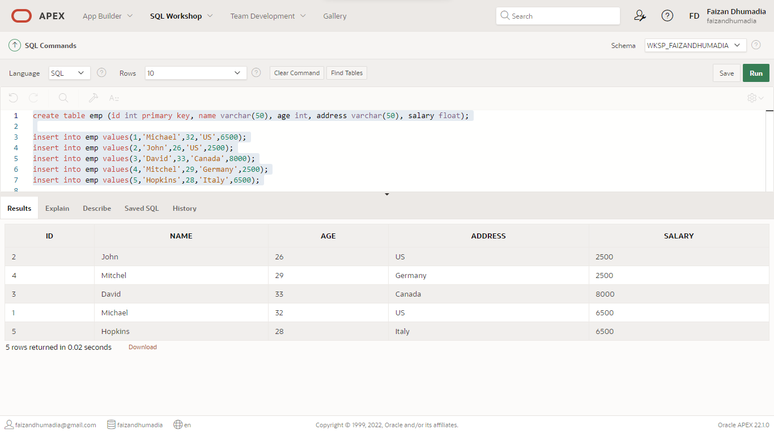

1. PL/SQL block to increase salary

DECLARE

total_rows number(2);

BEGIN

UPDATE emp SET salary = salary + 5000 where salary < 5000;

IF sql%notfound THEN

dbms_output.put_line('no employee updated');

ELSIF sql%found THEN

total_rows := sql%rowcount;

dbms_output.put_line( total_rows || ' employee updated ');

END IF;

END;

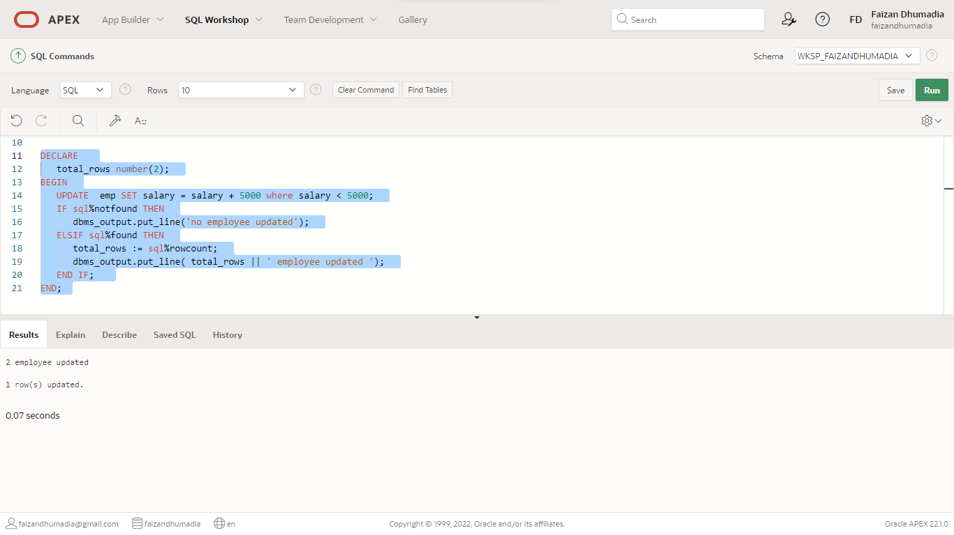

2. Explicit cursor

DECLARE

c_id emp.id%type;

c_name emp.name%type;

c_age emp.age%type;

c_addr emp.address%type;

c_salary emp.salary%type;

ctg_young number(2) :=0;

ctg_old number(2) :=0;

CURSOR c_emp is

SELECT id, name,age, address, salary FROM emp;

BEGIN

OPEN c_emp;

dbms_output.put_line('ID | Name | ADDRESS | Salary | AGE | Category');

LOOP

FETCH c_emp into c_id, c_name, c_age, c_addr,c_salary;

EXIT WHEN c_emp%notfound;

IF c_age > 18 and c_age < 40 THEN

dbms_output.put_line(c_id||' | '||c_name||' | '||c_addr||' | '||c_salary||' | '||c_age||' | '||' Young ');

ctg_young := ctg_young+1;

ELSIF c_age > 40 THEN

dbms_output.put_line(c_id||' | '||c_name||' | '||c_addr||' | '||c_salary||' | '||c_age||' | '||' OLD ');

ctg_old := ctg_old+ 1;

END IF;

END LOOP;

dbms_output.put_line('Total: '||ctg_young||' Young and '||ctg_old ||' Old employees');

CLOSE c_emp;

END;

